HANDOUT
OpAMP Design Simulation
HL
This analog sensor interface design circuit is utilized to handle 4-20 mA from an analog sensor output. Note the load resistor of 125 Ohm is needed to convert 4mA to 0.5 VDC, and 20mA to 2.5VDC

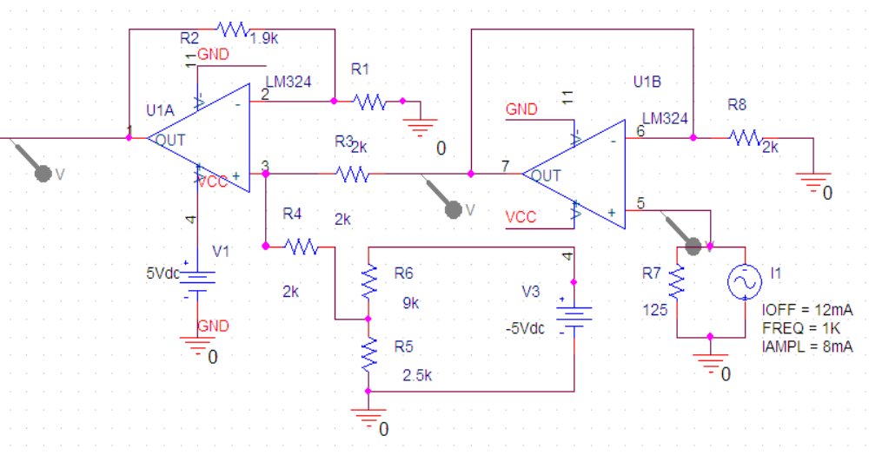

Figure 1. The gain unit, buffer unit for analog sensor input (current source) and the voltage bias unit (to bring 0.5 VDC down to 0 VDC).

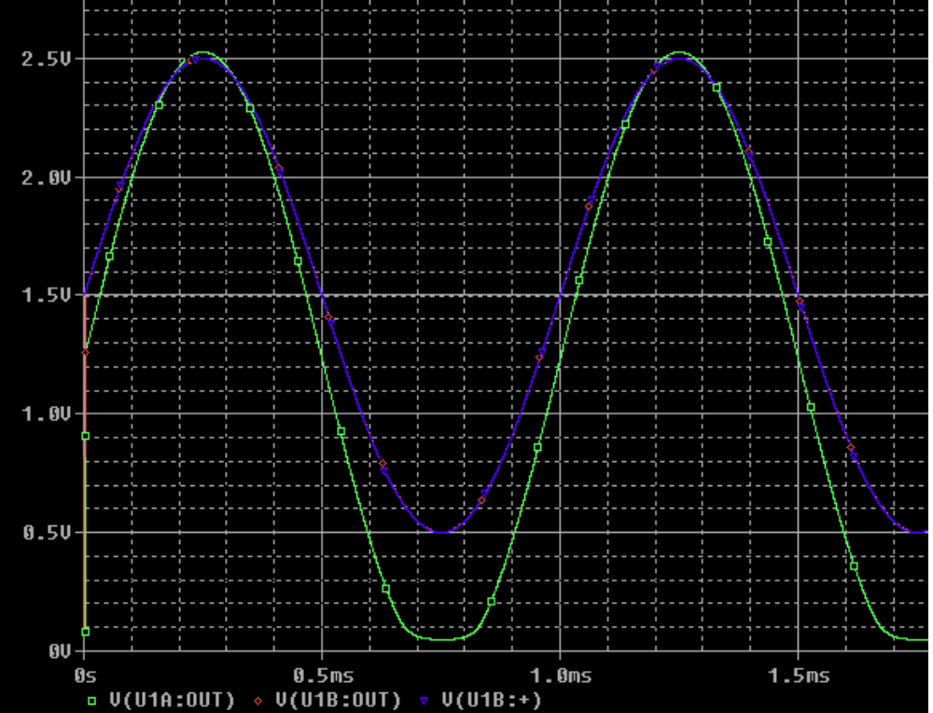

Figure 2. The green curve is the output, while the blue is the input. The input current source is
[4mA, 20mA].

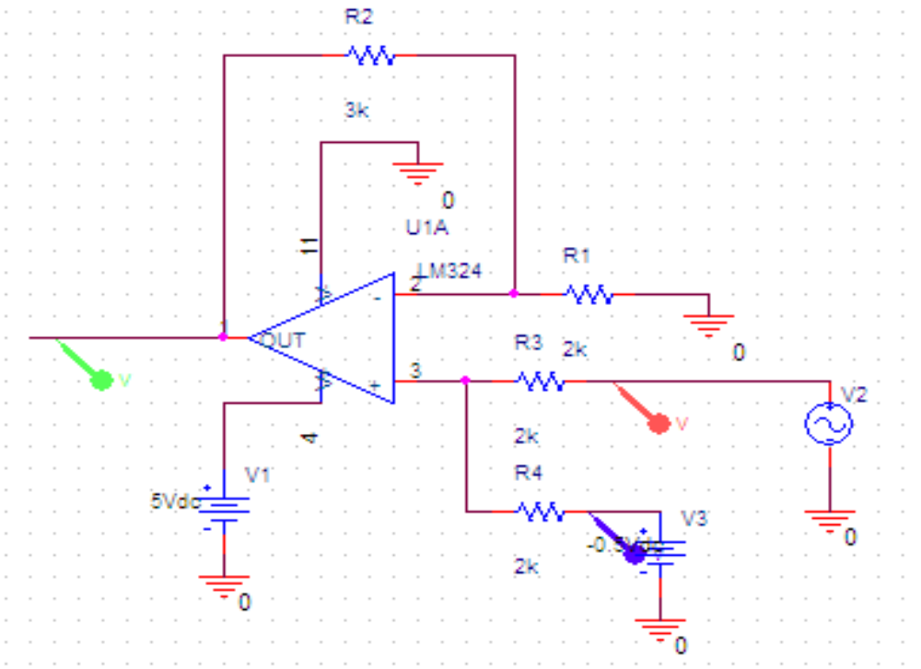

Figure 3. The schematics for testing Opamp LM324.

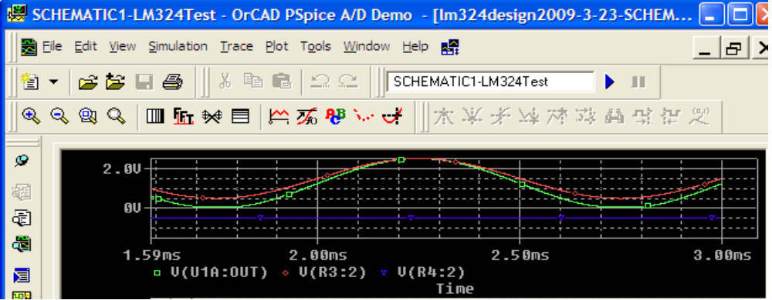

Figure 4. The testing result of LM324.
(END)

